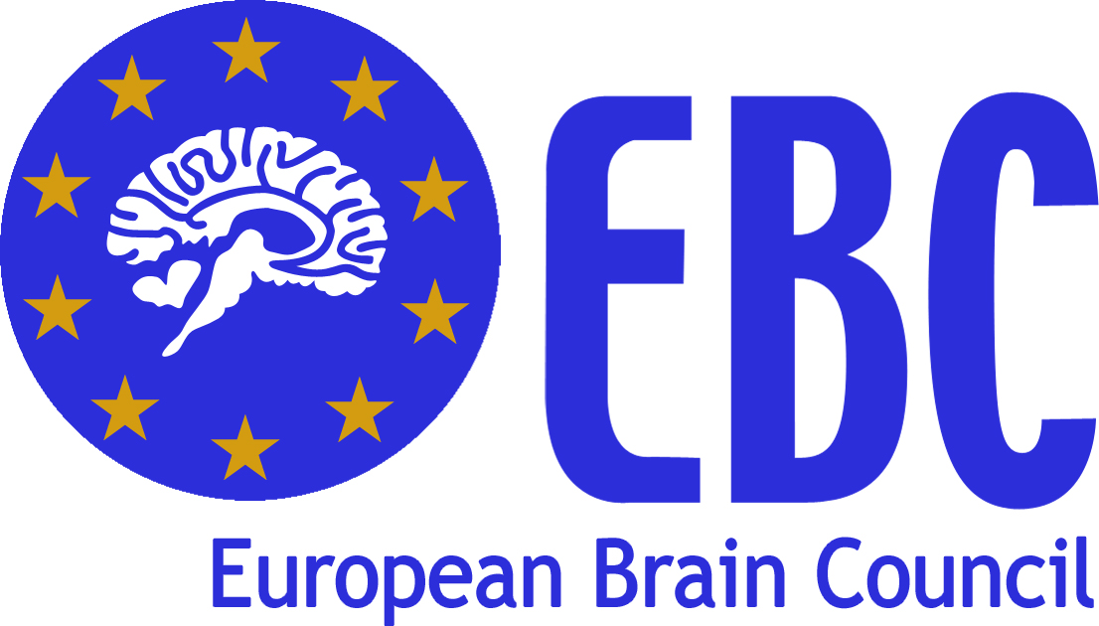





Rare NEUROLOGICAL Diseases OF childhood

we treat the child to treat the adult

December 2nd 2010
European Parliament, Room J6Q1
Bruxelles, Belgium

REGISTRATION FORM

FIRSTNAME

LASTNAME

ORGANISATION

FUNCTION

DATE OF BIRTH

COUNTRY OF RESIDENCE

PASSPORT PHOTOGRAPH ID CARD

TO BE SENT BY NOVEMBER 15TH 2010 TO: Ms. Marianna Parisi at OIC srl

EMAIL: m.parisi@oic.it

FAX NUMBER: +39 055 5528421

ADDRESS: OIC srl, Via Matteotti 7, 50121 Firenze, Italy

PLEASE NOTE: IF THIS FORM IS NOT RECEIVED BY NOV. 15TH YOU WILL NOT BE ALLOWED TO PARTICIPATE DUE TO THE EUROPEAN PARLIAMENT SECURITY REGULATION

